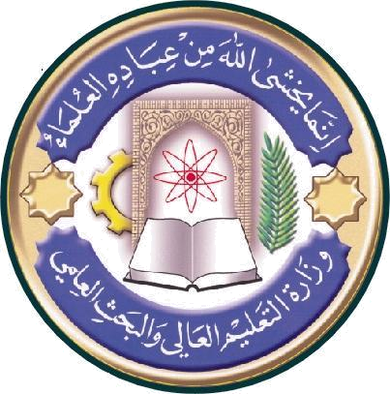
University:alnahrain
College:medicine
Department: Histology &embryology
Stage:Two
Lecturer name: May F.M Al Habib
Academic Status: Professor
Qualification: Ph. D
Place of work:Al Nahrain medical college

Republic of Iraq
The Ministry of Higher Education & Scientific Research

Course Weekly Outline

Course Instructor
  May Fadhil Majid AL Habib
E. mail | Mayalhabib@colmed-alnarain.edu.iq
Title | Professor
Course Coordinator | May Fadhil Majid AL Habib
Course Objective | The student acquires knowledge and skills in the subject of human histology. They should be able to recognize the microstructure of normal tissue and boy organs. The student appreciates the relevance of structure to functions and the close interrelationship between morphology, physiology, and pathology.
Course Description | Second semester
Textbook | Junqueira LC & Carneiro J (2005): Basic Histology; Text & Atlas. 11th ed. McGraw-Hill Medical. New York.
References | Leeson TS, Leeson CR & Paparo AA (1988): Text/Atlas of Histolog y. WB Saunders. USA.
Course Assessment | Mid-Term Tests | Laboratory | Quizzes | Project | Final Exam
Course Assessment | (15%) | (10%) | (5%) | ---- | (70%)
General Notes

University:alnahrain
College:medicine
Department: Histology &embryology
Stage:Two
Lecturer name: May F.M Al Habib
Academic Status: Professor
Qualification: Ph. D
Place of work:Al Nahrain medical college

Republic of Iraq
The Ministry of Higher Education
& Scientific Research

Course weekly Outline
week | Date | Topics Covered | Lab. Experiment Assignments | Notes
1 |  | Digestive Tract; General structure, the oral cavity and tongue. | Lip, tongue and types of papilla
2 |  | Pharynx and esophagus. | Taste buds and esophagus.
3 |  | Stomach and Small intestine | The Stomach.
4 |  | Large intestine & appendix | Small and Large
5 |  | Organs associated with the digestive tract; . Pancreas.and salivary glands | Pancreas, parotid and sub maxillary glands
6 |  | Liver, gall bladder and biliary tract. | Liver and bile duct, and gall bladder
7 |  | Respiratory System; Nasal cavity, , larynx | Olfactory epith, pharynx larynx
8 |  | Trachea and bronchial tree. | Trachea& bronchial tree.
9 |  | The Lung | lung
10 |  | The Urinary System I. The Kidney and nephrons | The Urinary System. the kidney and tubules
11 |  | The Urinary System II. Specialized vascularity and blood supply, ureter | The Urinary System Ureter, PAS sections in kidney urinary
12 |  | The Urinary System urinary bladder, urethra (male and female | bladder, urethra
13 |  | Endocrine Glands;. Pituitary gland. | Pituitary,
14 |  | Endocrine Glands; Suprarenal Glands. | suprarenal,
15 |  | Endocrine Glands; thyroid and parathyroid glands. | Thyroid and parathyroid glands.
16 |  | Mid-term Examination (Theory). | Mid-term Examination  practical
17 |  | The Male Reproductive System; Testes. | Testes .The Male Reproductive System.
18 |  | The Male Reproductive System; Accessory genital glands. | Prostate , vas deference
19 |  | The Female Reproductive System; Ovaries & oviducts. | Ovaries & oviducts.
20 |  | Uterus general arrangement and layers | Uterus and its stages
21 |  | Uterus cyclic phases
22 |  | Cervix and vagina | Cervix and vagina
23 |  | Mammary glands. | Stages in mammary glands
24 |  | Organs of Special Senses; Eye layers arrangement. The sclera | The eye
25 |  | Organs of Special Senses; Eye the choroid | The eye
26 |  | Organs of Special Senses; Eye. The retina | The eye
27 |  | Organs of Special Senses; Ear I | The eye
28 |  | Organs of Special Senses; Ear II | The eye
29 |  | Organs of Special Senses in the skin | Touch corpuscles
30 |  | Revision and overview | Revision

Instructor Signature: Dean Signature:

