بسم الله الرحمن الرحيم
University: Al-Nahrain
College: Medicine
Department: Chemistry and Biochemistry
Stage: PhD / First semester
Lecturer name: Dr. Omar F. Abdul- Rasheed
Qualification: Assistant Professor
Place of work: Chemistry and Biochemistry Department

Republic of Iraq
The Ministry Of Higher Education
& Scientific Research
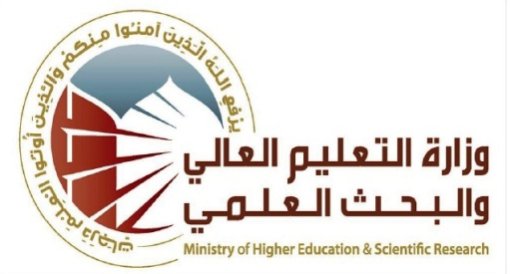

Flow up of implementation celli pass play
Course Instructor | Dr. Omar F. Abdul- Rasheed
E-mail | Omar. reasheed@colmed-alnahrain.edu.iq
Title | Clinical Endocrinology
Course Coordinator | Dr. Najat Abdul-Razaq Hasan
Course Objective | The student should be able to:  • understand the function of the endocrine organs, metabolism of their hormones, and their effects on the body.  • understand the pathogenesis and pathophysiology of diseases of the pituitary, thyroid, parathyroid, adrenal, pancreas (endocrine), testes, and ovary.  • interpret the results of measurements of stimulation and suppression of glands.
Course Description | The course involves the discussion of different cases related to many endocrine functions like hypothalamus- pituitary- adrenal axis, thyroid function tests as well as infertility problems with endocrine origin.
Textbook | Clinical chemistry and metabolic medicine, Martin A. Crook, 7th edition(2006)  Clinical Chemistry. William J. Marshal. 4th edition (2000)
Course Assessments | Term Tests | Laboratory | Quizzes | Project | Final Exam
 | (30%) | - | - | - | (70%)
General Notes | Type here general notes regarding the course

University: Al-Nahrain
College: Medicine
Department: Chemistry and Biochemistry
Stage: Master / First semester
Lecturer name: : Dr. Najat Abdul-Razaq, Dr. Omer F. Abdul Rasheed, and Dr. Rayah S. Baban,
Qualification: Prof. and Assistant Professor
Place of work : Chemistry and Biochemistry Department

Republic of Iraq
The Ministry Of Higher Education
& Scientific Research

Course Weekly Outline
Week | Date | Topics Covered | Lab. Experiment Assignments | Notes
1 |  | Introduction, classification and mode of action |  | Dr. Najat Abdul-Razaq
2 |  | The hypothalamus and pituitary gland hormones |  | Dr. Najat Abdul-Razaq
3 |  | The adrenal gland |  | Dr. Omar F. Abdul Rasheed
4 |  | The gonads |  | Dr. Omar F. Abdul Rasheed
Mid Exam
5 |  | GIT hormones |  | Dr. Omer F. Abdul Rasheed
6 |  | Leptin |  | Dr. Najat Abdul-Razaq
7 |  | The parathyroid gland and calcium homeostasis |  | Dr. Rayah S. Baban
8 |  | The thyroid gland |  | Dr. Rayah S. Baban
9 |  | Glucose regulating hormones |  | Dr. Rayah S. Baban
INSTRUCTOR Signature: Dean Signature:

