بسم الله الرحمن الرحيم
Republic of Iraq
The Ministry Of Higher Education
& Scientific Research
University: Al-Nahrain
College: Medicine
Department: Chemistry and Biochemistry
Stage: Master / First semester
Lecturer name :Dr. Rayah S. Baban
Dr. Estabraq Abdul Rasoul
Qualification: Assistant Professor
Place of work: Chemistry and Biochemistry Department

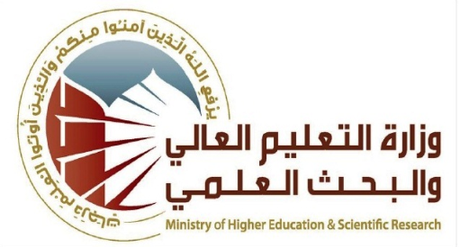

Flow up of implementation celli pass play
Course Instructor | Dr. Rayah Sulaiman Baban
E-mail | baban.r9@gmail.com
Title | Hormones
Course Coordinator | Dr. Raid J. Mohammad
Course Objective | - to review the definition and classification of hormones with the students  - to inform students; synthesis, storage and transport of the hormones.  - to review the hypothalamus-pituitary-glands axis  - to inform students about the way of hormones regulation.
Course Description | Type here course description
Textbook | Lecture notes of Clinical Chemistry
Course Assessments | Term Tests | Laboratory | Quizzes | Project | Final Exam
Course Assessments | (30%) | - | - | - | (70%)
General Notes | Type here general notes regarding the course

University: Al-Nahrain
College: Medicine
Department: Chemistry and Biochemistry
Stage: Master / First semester
Lecturer name: :Dr. Rayah S. Baban
Dr. Estabraq Abdul Rasoul
Qualification: Assistant Professor
Place of work : Chemistry and Biochemistry Department

Republic of Iraq
The Ministry Of Higher Education
& Scientific Research

Course Weekly Outline
Week | Date | Topics Covered | Lab. Experiment Assignments | Notes
1 |  | Definition and classification |  | Dr. Estabraq Abdul Rasoul
2 |  | Biosynthesis, storage, transport |  | Dr. Estabraq Abdul Rasoul
3 |  | Mechanism of action of steroid hormones |  | Dr. Estabraq Abdul Rasoul
4 |  | Mechanism of action of protein hormones |  | Dr. Estabraq Abdul Rasoul
5 |  | Receptors and diseases |  | Dr. Estabraq Abdul Rasoul
6 |  | Second messengers |  | Dr. Estabraq Abdul Rasoul
7 |  | Hypothalamus and pituitary hormones |  | Dr. Estabraq Abdul Rasoul
8 |  | Regulation of hormone secretion |  | Dr. Estabraq Abdul Rasoul
9 |  | Insulin synthesis, secretion and metabolic role; diabetes mellitus |  | Dr. Rayah S. Baban
Mid- Term Exam.
10 |  | Glucagon, clinical aspects |  | Dr. Rayah S. Baban
11 |  | Thyroxin; synthesis and metabolism  Hypo and hyper Thyroidism  Goiter |  | Dr. Rayah S. Baban
12 |  | Catecholamines |  | Dr. Rayah S. Baban
13 |  | Reproductive hormones and infertility |  | Dr. Rayah S. Baban
INSTRUCTOR Signature: Dean Signature:

